Unit 5 Quadrilaterals Review Sheet

**State how you could prove (combination of slope, distance, or midpoint formula) the following properties on the coordinate plane.**

1. 
2. Δ*ABC* is equilateral.
3. Quadrilateral *ABCD* is a square.
4. The diagonals of a quadrilateral form right angles.
5. Quadrilateral *ABCD* is a trapezoid.
6. Δ*ABC* is a right triangle.
7. Quadrilateral *ABCD* is a kite.
8. Quadrilateral *KLMN* is an isosceles trapezoid.

**Find the sum of the interior angle measures of each polygon.**

**1.** 21-gon **2.** 42-gon

**Find the measure of one interior angle in each regular polygon.**

**1.** 50-gon **2.** 205-gon

**Find the missing angle measures.**

1. 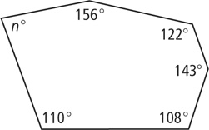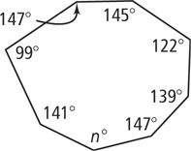 **2. 3.**

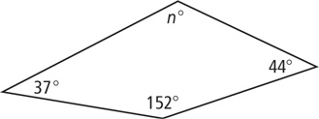

**The sum of the angle measures of a polygon with *n* sides is given. Find *n.***

**1.** 900 **2.** 1440 **3.** 2340

**Find the measure of an exterior angle of each regular polygon.**

**1.** 12-gon **2.** 24-gon **3.** 45-gon

**Find the value of the variables in each parallelogram.**

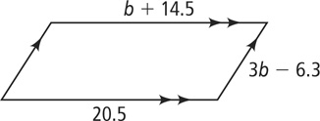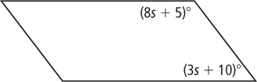

***QRST* is a rectangle. Find the value of *x* and the length of each diagonal.**

1. *QS* = 6*x* − 3 and *RT* = 4*x* + 19

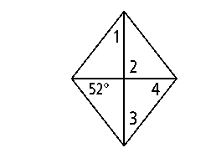**Find the measures of the numbered angles in the rhombus.**

**Find the value of the variables and then substitute to find the lengths.**

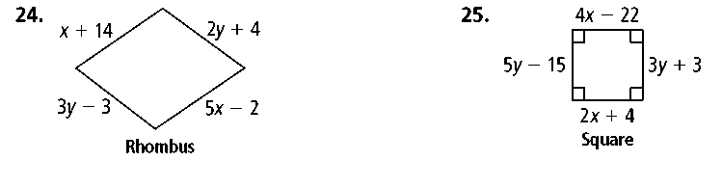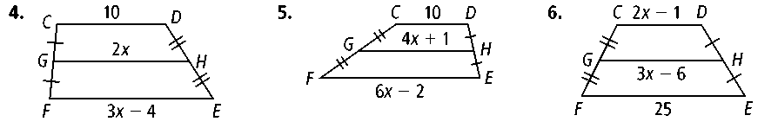

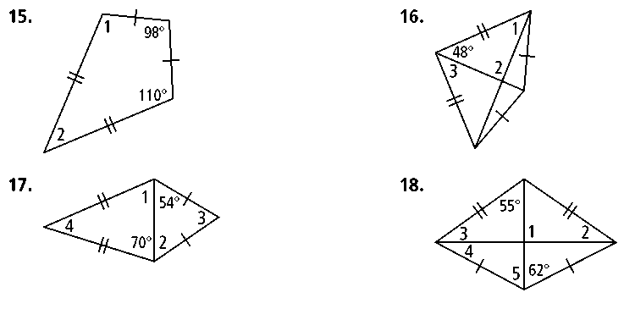**Find all of the numbered angles.**

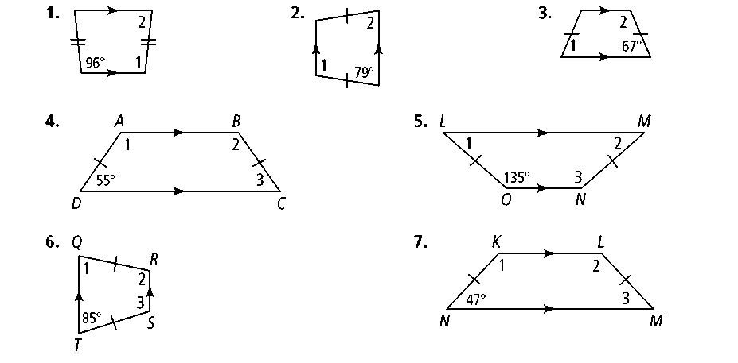

**Mixed Coordinate Proofs**

*Graph the quadrilaterals on the axes and determine what type of quadrilateral they are.*

1.

Screen%20Shot%202016-12-07%20at%2011.31.15%20PM.png

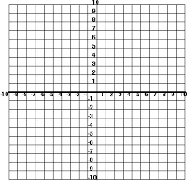

2. *A*(−6, 3), *B*(−2, 0), *C*(−2, −5), *D*(−6, −2)



3. *A*(1, 8), *B*(4, 6), *C*(1, −2), *D*(−2, 0)



4. *A*(3, 4), *B*(8, 1), *C*(2, −9), *D*(−3, −6)



5.   
Screen%20Shot%202016-12-07%20at%2011.36.51%20PM.png  
